

Digital Health Modernization/
Medical Records (MHV to VA.gov)

Version 6

Revision History
Date | Version | Description | Author
11/15/24 | 6 | Download Reports (CCDA, Self entered, Download all) and Medical Images domain | Lichelle Bain
9/09/2024 | 5 | Error message updates, section 5 and Landing page updates, section 4.1 | Lichelle Bain
8/23/2024 | 4 | Labs and Tests updates, section 4.2 | Lichelle Bain
6/04/2024 | 3 | Sections 4.2, 4.8, and 4.9 | Lichelle Bain
5/03/2024 | 2 | Product update | Lichelle Bain
8/14/2023 | 1 | Product debut | Amelia Hacking

Table of Contents
Revision History 2
Table of Contents 3
1. Product Overview 4
1.1 Assumptions / Standards 4
Device Responsiveness 4
4
Accessibility Guidelines 5
Alerts 5
1.2 Print and Download 6
1.3 What is Not Included in Medical Records 8
2. User Access 8
2.1 Login Methods 8
3. Navigation 9
3.1 Left Navigation (as seen in Figure 9) 9
3.2 Breadcrumbs 9
3.3 Pagination 10
4. Functionality 10
4.1 Landing page 11
4.2 Lab and test results 12
4.3 Care summaries and notes 13
4.4 Vaccines 14
4.5 Allergies and reactions 15
4.6 Health conditions 16
4.7 Vitals 17
4.8 Radiology Reports and Images 18
4.9 Download your medical records reports 19
5.0 Medical electronic records settings 21
5. Major Issues and Error Messages 22
6. Table of Figures 24

1. Product Overview
Medical Records on VA.gov will provide Veterans with the same ability to securely review their medical records that exists on My HealtheVet (MHV) today. Veterans will be able to view, print, or download their records as a list or a group, but can also view, print, and download individual records, like a single blood panel. Veterans will be able to opt in and out of VHIE sharing settings, manage their notification settings, and download a comprehensive report of all of their records contained within this tool. The new application will employ modern technology and user-centered design to ensure that the tool is accessible, straightforward, and simple to use, and Veterans will have an easier time accessing their important information. Moving this product out of My HealtheVet and into the VA.gov landscape will also provide a more seamless and consistent experience than was possible on two distinct websites.
1.1 Assumptions / Standards
To maintain consistency across Medical Records, there are some approaches that are used throughout the experience to note.
Device Responsiveness
The entire experience is mobile responsive, meaning that as it is viewed on small factor devices (tablets and phones) the elements will shrink to provide users with an optimal mobile-friendly experience (Figure 1).
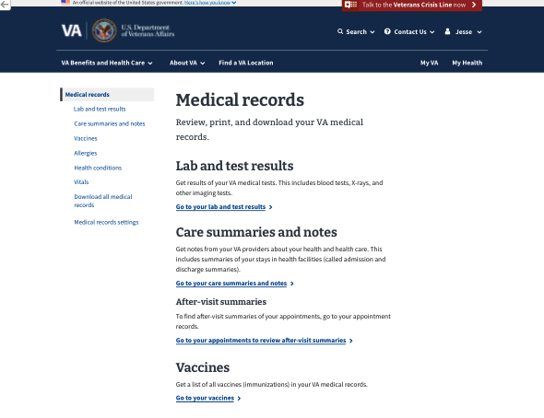
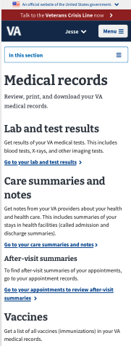

Figure 1: Desktop and mobile landing pages

Accessibility Guidelines
Medical records on VA.gov is committed to upholding all accessibility guidelines. This tool and its features are designed to be easily perceived, operated, understood, and robust, regardless of how they are accessed or the user's physical, cognitive, or technological abilities. The design and development process has involved close collaboration with accessibility specialists to guarantee that this product fulfills all accessibility standards.
Alerts
Alerts also appear within the Medical Records tool. We use them to inform the Veteran about successful actions or empty records sections. These are some of the alerts that appear within Medical Records as needed:
Download started  This alert lets the Veteran know the download has started, but the system needs verification of the device’s download location for the file (Figure 2). |   Figure 2: Download started alert
Successful download  This alert lets the Veteran know that their records were successfully downloaded. We provide this positive feedback to decrease confusion and prevent Veterans from downloading something multiple times because they aren’t sure if it worked the first time or not (Figure 3). |   Figure 3: Successful download alert
Sharing settings successfully updated  This alert tells Veterans that their sharing settings were successfully changed. This is important feedback, because the ability to update these settings is an essential part of Veterans’ ownership of their medical records (Figure 4). |   Figure 4: Sharing settings successfully updated alert
No records in domain  If a Veteran has no records in a certain section of Medical Records (example: lab and test results), this alert will appear in place of the list of records. This informational alert can help Veterans understand why a certain section of the Medical Records tool may be empty (Figure 5). | Figure 5: No records in domain alert
1.2 Print and Download
The ability to print and download medical records is an essential and important part of the Veteran’s experience throughout the Medical Records tool. On various pages, Veterans will be presented with a new print/download button, allowing them to print the list or record they are viewing, or download it as a PDF or text file, depending on their needs (Figure 6).
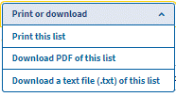
There are two use cases for this button: Downloading/printing a single medical record – a specific individual record of a domain found within the details page of a record, e.g., a flu vaccine; and downloading/printing a list of a particular domain, e.g., all vaccines available in the patient’s record.
Figure 6: Print or download button
On the “Download all medical records” page, Veterans are presented with two links – one to download their entire medical record as a PDF, and one to download it as a text file (Figure 7). We included the file size in our designs so that Veterans are not surprised by the large file sizes.

Figure 7: Print or download links
1.3 What is Not Included in Medical Records
- Self-entered data will not appear in the new Medical Records tool. In Phase 0, users will be directed back to MHV Classic to view and add self-entered data. In the future, they may be able to access historic data.
- Care summaries and notes prior to 2013 will not appear within this tool.
- EKGs after March 2022 are not viewable through this tool. EKGs prior to March 2022 are only viewable as the date the EKG was performed, but results and imaging are not available.
- Medications are not part of this Medical Records tool, but will be available in a different part of MHV on VA.gov.
- After-visit summaries are not included in Medical Records, but can instead be found in the Appointments section of VA.gov.
2. User Access
In the initial release (Phase 0), functionality will not be linked directly to VA.gov. Specific pilot/beta users will be invited to use the experience and their account emails will be ‘whitelisted’ which will allow them entry into the new experience.
Users that are invited to the new experience will need to authenticate into VA.gov and then navigate directly to the URL they will be provided. They, along with other non-invited users, can still access their legacy/existing MHV Medical Records experience by following the links in VA.gov.
2.1 Login Methods
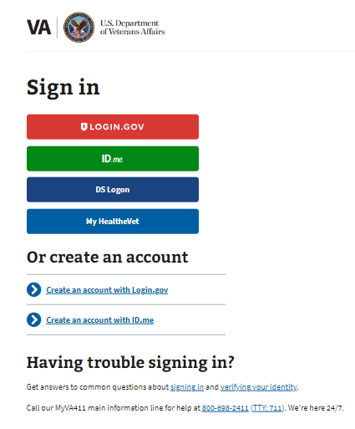
Invited users will be provided the URL to the new experience, which can be accessed by going to https://www.va.gov/my-health/medical-records/. Upon accessing this URL, users will have the ability to login using one of the existing VA.gov login options (Figure 8).
Figure 8: Logging into VA.gov
Unauthorized users will be redirected to this static page https://staging.va.gov/health-care/medical-records/

3. Navigation
To navigate around Medical Records on VA.gov, Veterans are provided with several different navigation techniques.
3.1 Left Navigation (as seen in Figure 9)
- Medical records serves as the landing page.  - Lab and test results is where Veterans can access results of their medical tests and lab.  - Care summaries and notes is where Veterans can get notes from their VA providers about their health care.  - Vaccines is where Veterans can get records of which vaccines they have received and when.  - Allergies is where Veterans can review their documented allergies.  - Health conditions is where Veterans can review a list of health conditions that their VA providers are helping them manage.  - Vitals is where Veterans can review their basic health numbers that their providers check at appointments.  - Download all medical records is where Veterans can download all their records as a single file.  - Medical records settings allow Veterans to view and change their medical records sharing and notification settings. | 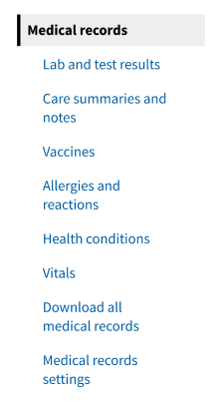  Figure 9: Left navigation
3.2 Breadcrumbs
Throughout the Medical Records experience, we have provided a back breadcrumb to help Veterans navigate through the experience more easily (Figure 10). They will appear on every page, except the Medical records landing page. The breadcrumb will take Veterans back to the previous level of the navigation menu.

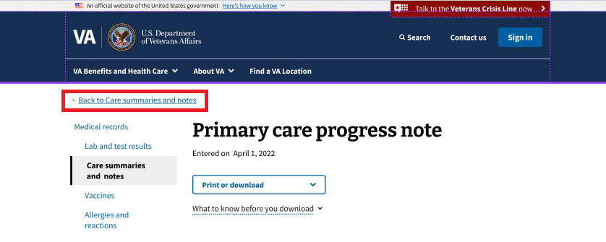
Figure 10: Back breadcrumbs
3.3 Pagination
There are several uses of list views throughout the Medical Records experience. It is possible for a single section of Medical Records to contain hundreds of records, and so pagination is used to separate those records into shorter, more manageable lists to decrease the cognitive load and increase usability for Veterans. At the top of the list, we tell Veterans how many records are currently being displayed, how many records total we have, and that they are automatically sorted from newest to oldest (Figure 11). At the bottom of the list, we have page numbers and a next button that lets Veterans navigate through the rest of their records (Figure 12).


Figure 11: Top of pagination

Figure 12: Bottom of pagination
4. Functionality
Users of Medical Records can navigate throughout the experience using the aforementioned navigation patterns. Below is a description of the various types of functionalities that users can perform while authenticated.

4.1 Landing page
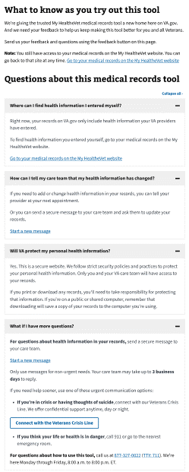
The Medical Records landing page acts as a home base for Veterans to help them understand what exists in the medical records tool for them to use. There are two major sections: an explanation of the different navigation options (Figure 13), and a Q&A section that reviews some common questions that Veterans may have about using this tool (Figure 14).
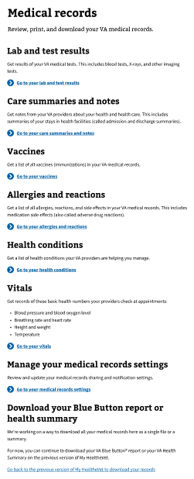
Figure 13: Landing page navigation descriptions
Figure 14: Landing page question and answers

4.2 Lab and test results

The lab and test results page allows Veterans to review results from their medical labs and tests, such as blood tests, x-rays, and other imaging tests (Figure 15). The page includes an explanation of when Veterans can expect to find their results here, to decrease confusion about why a recently-done test or lab may not be available to view. The pagination makes it clear that records are sorted from newest to oldest, and then the different tests are displayed in a card format with basic information about the test, including the name of the lab or test, date of the lab test, type of lab or test, and the name of the provider who ordered the lab or test, with a link that will take Veterans to a different page to view the detailed results of their lab or test.
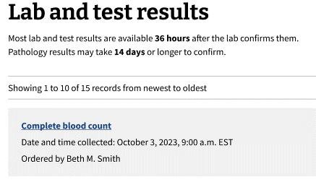
The detailed view includes the option for Veterans to print or download their lab or test result, and then displays important information again such as the type of test, sample tested, ordering provider, as well as the ordering and collecting locations and any lab comments that are applicable. Many lab and test results include a results and a reference range for results that defines what is considered to be a “normal” result, and so we have included an informational alert that lets Veterans know that if their results are outside of the standard range, this is not immediate need for concern and they should contact their provider if they need help interpreting their results to understand what they mean for their individual circumstance and condition (Figure 16).
Figure 15: Lab and test results header and card view
Figure 16: Lab and test results details page

Figure 16: Detailed view of a chemistry and hematology test
4.3 Care summaries and notes
The care summaries and notes page allows Veterans to view notes about their care that their providers have entered (Figure 17). Veterans can view primary care progress notes, admission and discharge summaries, non-VA care consult notes, and administrative notes. Notes entered before 2013 and after-visit summaries will not appear in this list. Notes will appear in a card format, like the other list pages throughout medical records. Cards will display the type of note, the date of the note, the location of the facility that wrote the note, the admitting or signing physician as applicable, with a link that will take Veterans to a different page to view the detailed results of their care summary or note.
The detailed view includes the option for Veterans to print or download the note, and then displays important information again such as the location, any applicable dates, the signing or admitting physician, as well as the status of the note. Then the actual note is displayed in the format that the provider has entered it (Figure 18).
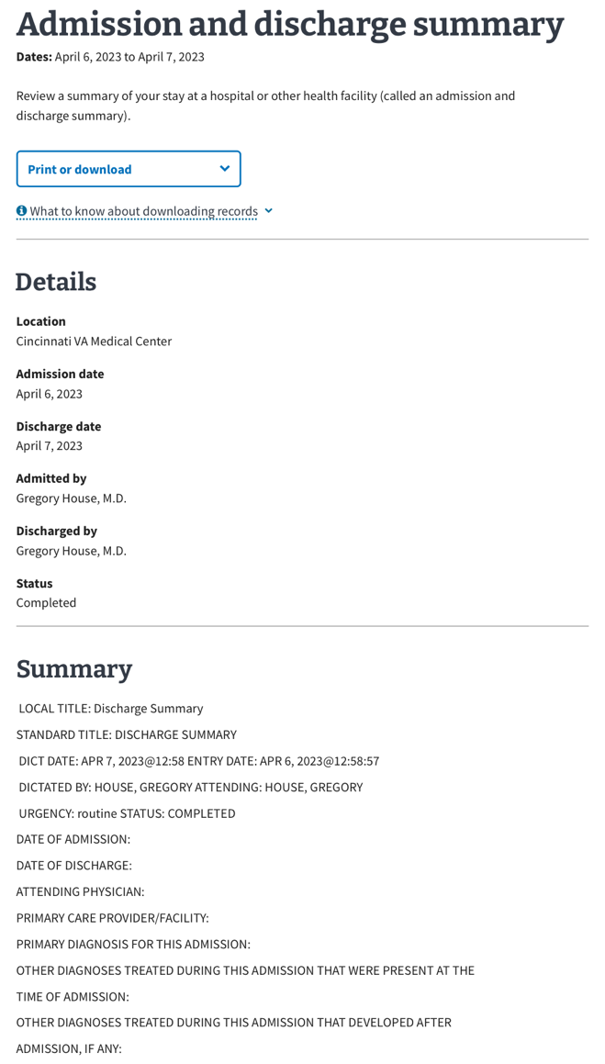
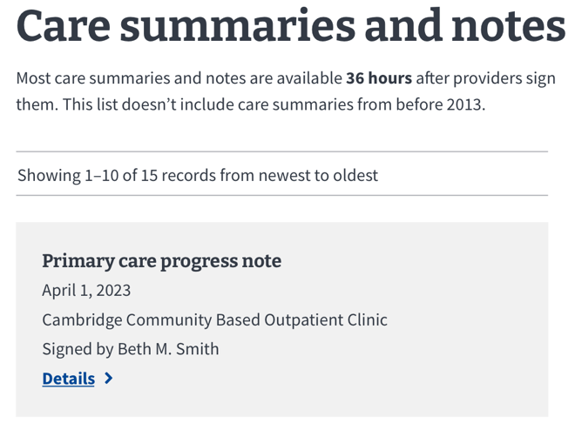
Figure 17: Care summaries and notes header and card view

Figure 18: Details view of an admission and discharge summary
4.4 Vaccines
The vaccines page allows Veterans to view a list of every vaccine they receive and have the option to print or download the list of all of their vaccines (Figure 19). Vaccines are displayed in the previously discussed card format, and show the vaccine short name, the date the vaccine was received, and the location at which they received the vaccine, with a link that will take Veterans to a different page to view the details of the vaccine.
The detailed view includes the option to print or download the individual vaccine record, as well as important details including the manufacturer, location, and any reaction or notes that the provider has included (Figure 20).
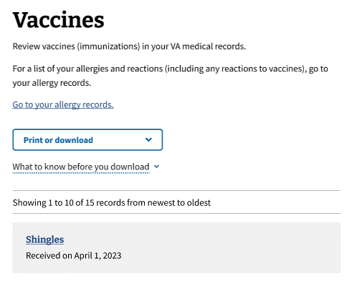
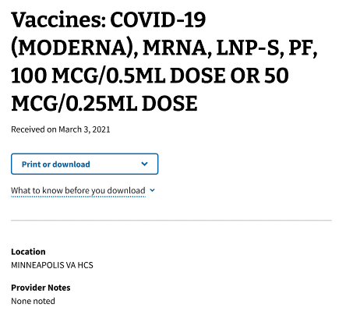
Figure 19: Vaccines header and card view
Figure 20: Vaccine details view

4.5 Allergies and reactions
The allergies page allows Veterans to view a list of all their recorded allergies (Figure 21). This list only includes allergies entered in by VA providers and does not include any self-entered allergies. If Veterans wish to add an allergy to their list, they may send a secure message to their care team through the link that we provide on this page, or by accessing the secure messaging portion of MHV. Veterans can download or print the list of their allergies. Any allergies are displayed in cards, and list the title, date entered, and a link to view the allergy in detail.
In the detailed view, Veterans can also download or print the report. Important details of the allergy are displayed, including the reaction to the allergen, the type of allergy, the drug class (if it’s a drug-related allergy), as well as the location of the provider who entered it, whether this allergy was directly observed by a care team member or only reported, and then any notes that the provider has entered (Figure 22).

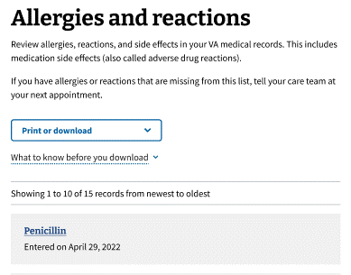
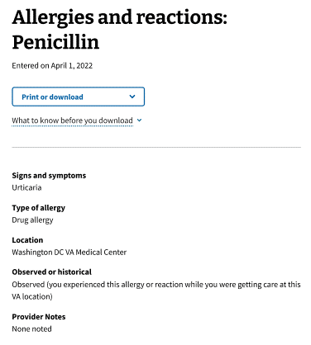
Figure 21: Allergies header and card view
Figure 22: Allergy details view

4.6 Health conditions
The health conditions page gives Veterans access to a list of their recorded health conditions that their VA providers are helping them manage (Figure 23). Health conditions are displayed in card format with the name of the health condition, the date entered, and a link to take Veterans to a page that displays the condition in more detail.

The detailed view includes an option to print or download this report. It also displays information about the health condition including the provider that entered the condition, any provider notes, the status of the health condition, the location of the facility, and the clinical term for their condition (Figure 24).

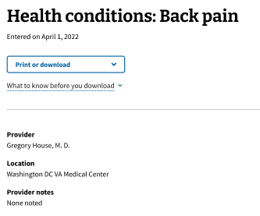
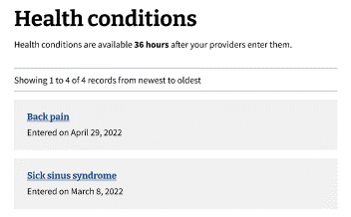
Figure 23: Health conditions header and card view
Figure 24: Health condition details view

4.7 Vitals
The vitals page allows Veterans to view their vitals (Figure 25). It is different from the other list views, because it displays a set list of vitals with the most recent reading. The vitals listed are:
- Blood pressure
- Heart rate
- Breathing rate
- Blood oxygen level
- Pain level
- Temperature
- Weight and
- Height
Each vital is listed in a card with the name of the vital, the result, the date of the last reading, and the location of the facility that recorded it. Then there is a link that Veterans can click that will take them to a new page to view all of their records within that vital (Figure 26).
The detailed results can be printed or downloaded, and then are displayed from newest to oldest. The date, measurement, location, and provider notes are displayed for each reading.
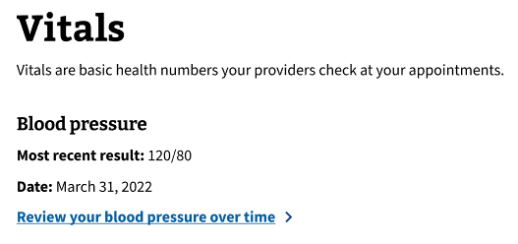
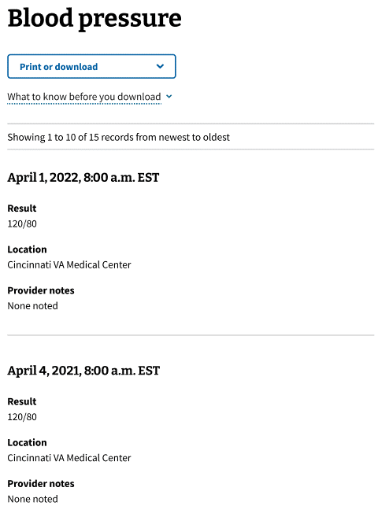
Figure 25: Vitals header and card view
Figure 26: Vitals - View results over time

4.8 Radiology Reports and Images
The ‘Radiology Reports and Images’ feature allows Veterans to view available VA Medical Images and Reports within the Labs and tests results list view (Figure 27).
A user’s Radiology report is displayed on the details page and images are available to request from the details page of the desired report (Figure 28). If images are available, the user will be presented with the “Request images” button at the bottom of the details page (Figure 29). Completed requests are available for 3 calendar days. If needed, veterans can submit the request again at any time.

Once the images have been loaded, the user can click on a “view images” link and be brought to a landing page for the images (Figure 30). There, the images can be viewed as JPEGs and saved to their device by simply using the device’s native image saving tools.

A user’s Digital Imaging and Communications in Medicine (DICOM file) is generated when they request images on a Radiology details page. Upon landing on the image page a link to download the file will appear at the bottom of the page. DICOM images are also known as diagnostic images can be used by veterans to present to their caregivers and non-VA health care providers.

Note: Not all radiology reports have associated images.

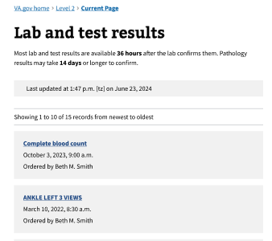

Figure 27: Radiology reports and images list view

Figure 28: Details view for Radiology report with request images button
Figure 29: Request images button
Figure 30: Images landing page with download DICOM option.

4.9 Download your medical records reports
The ‘Download your medical records reports’ page allows Veterans to download the Blue Button report in PDF format and other reports such as the Continuity of care document (VA Health Summary) and Self-entered health information (Figure 31).

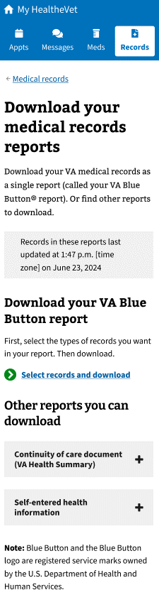

Figure 31: Download all your medical records reports header and other reports
5.0 Medical electronic records settings
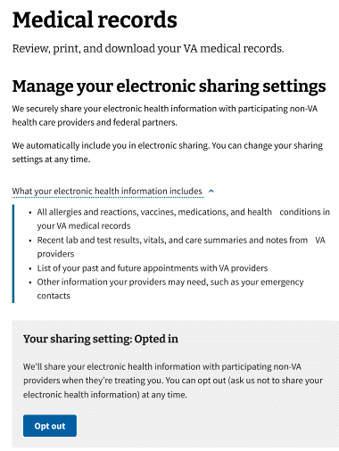
The ‘Medical records settings’ page allows Veterans to view and update their sharing settings and explains notification settings with a link to update those on the My HealtheVet website (Figure 32).
Figure 32: Manage your sharing settings
The sharing settings are the “Veterans Health Information Exchange program” (VHIE) and Veterans can opt in or out. On this page, we provide an explanation of what VHIE is, as well as what records are shared through that program. Veterans are automatically enrolled but can opt out at any time. We wanted to make the opt in/out process as easy as we could to increase usability for Veterans and empower them to understand what happens with their medical records. When Veterans select the opt in/out button, a modal opens up explaining what their decision will mean, and Veterans can confirm or cancel their decision (Figure 33). We also made it very clear whether a Veteran is opted in or out to decrease any confusion for Veterans about what was happening.
To manage their notification settings, Veterans will have to navigate to their profile. We provided a link directly to their profile to make that process easier as well (Figure 34).

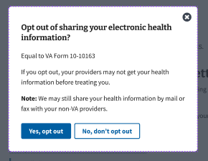
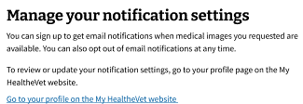
Figure 33: Opt out modal
Figure 34: Manage your notification settings

5. Major Issues and Error Messages
Error handling exists throughout the application. When a user completes a task, if the result does not complete for any reason, they are presented with an error message. These are some of the error messages built into Medical Records that will display as needed:
Can’t download records  This error message will display when there is an internal error preventing the Veteran from downloading their medical records (Figure 35). | 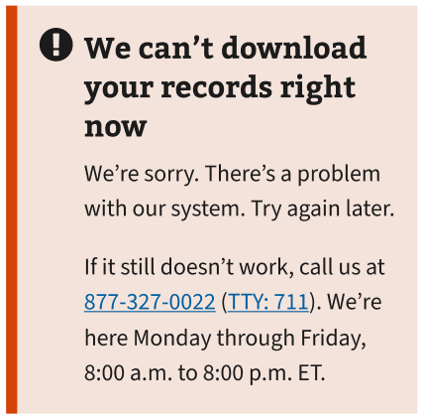  Figure 35: Can’t download records error
Can’t access records  This error message will display if there is an internal error preventing a Veteran’s records from being displayed within a domain (Figure 36). | 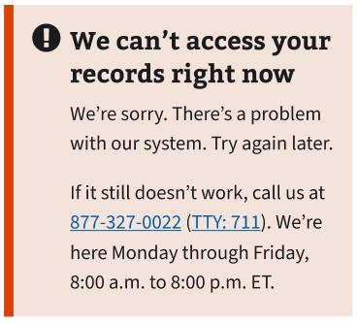  Figure 36: Can’t display records error
Can’t print records  This error message will display if there is an internal error preventing a Veteran’s record from being printed within a domain (Figure 37). | 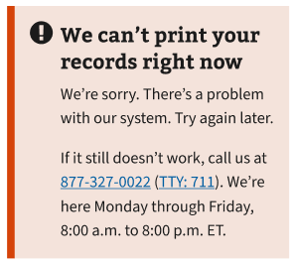  Figure 37: Error updating sharing settings
Can’t update records  This error message will display if there is an issue with the backend in updating the records to the most recent information (Figure 38). | 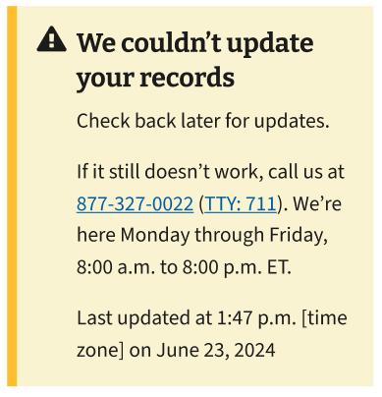  Figure 38: Error updating sharing settings
Error updating sharing settings  These error messages will display after a Veteran attempts to update their sharing settings but is unable to for an internal reason (Figure 39). | 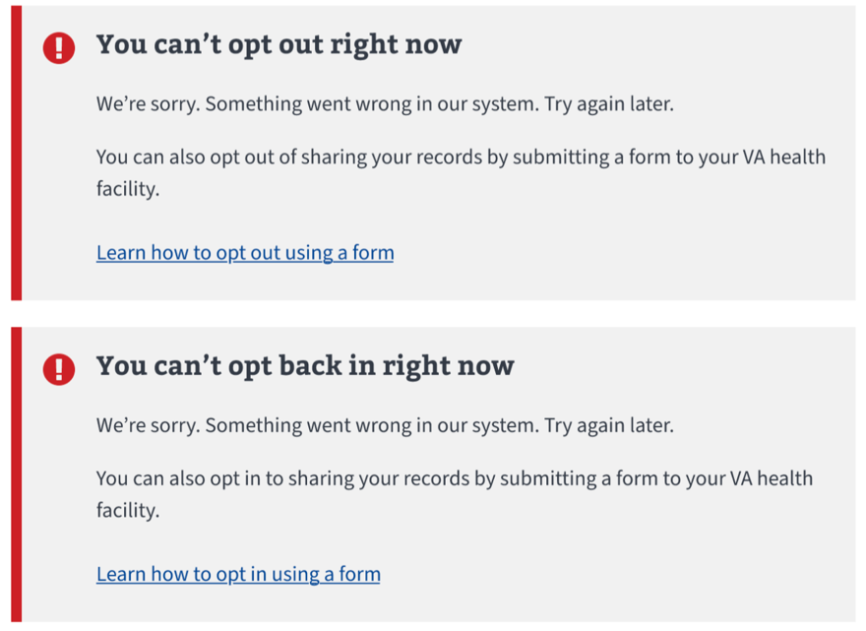  Figure 39: Error updating sharing settings
Error accessing sharing settings  If there is an internal error that prevents the sharing settings from being accessed, this will display in place of the sharing settings box (Figure 40). | 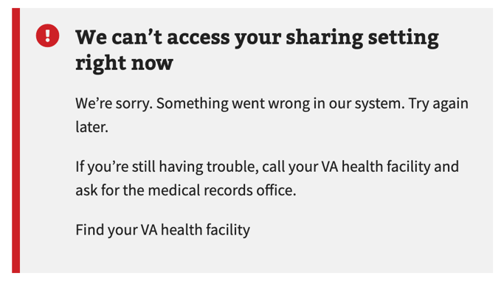  Figure 40: Error accessing sharing settings

6. Table of Figures
There is not a table of figures documented at this time.

